ADDRESS |  | JOB NO:
OPERATIVE NAME |  | TRADE
DATE OF WORKS |  | MANAGER

DETAIL THE TASK

WHAT  ARE THE HAZARDS?  Circle all that apply | 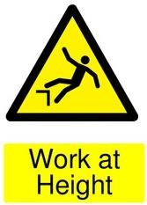 | 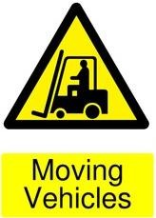 | 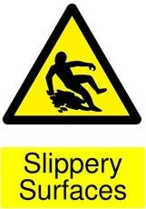 | 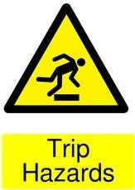 | 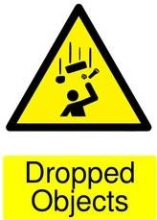 | 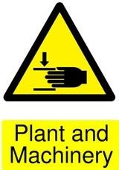 | 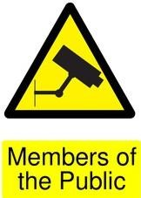
WHAT  ARE THE HAZARDS?  Circle all that apply | 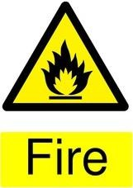 | 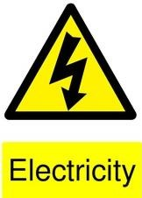 | 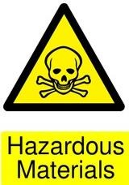 | 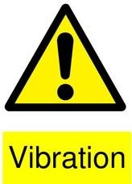 | 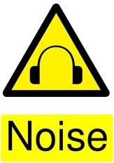 | 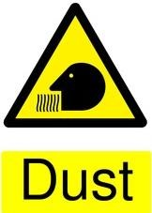 | 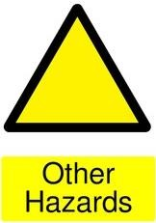

PLANNING THE JOB  ASK YOURSELF THESE QUESTIONS  Answer  Yes. No or N/A in the box | Are others affected by these works? |  | Do you have the correct tools for the job?
 | Are there EDC risk assessments available |  | Are tools in good working condition?
 | Do they fully apply to the job at hand? |  | Are work at height arrangements suitable and correctly erected / Installed?
 | Is a permit required for the task? |  | Is everyone aware of other activities in the work area?
 | Is the correct PPE available for the task? |  | Have all hazards been considered?
Hazard  Controls | Hazards:  What hazards did you find? | Controls:  What controls are in place?  What additional controls will you put in place? | Responsibilities:  Who is responsible for implementing these controls?

COMPLETION OF WORKS |  | Yes |  | No | COMMENTS
Are the works complete?
Is the work area clear?
Have all materials been removed from site?

Has the customer inspected works?

Have any permits issued been cleared?
Has a Team/Squad Leader inspected the works?

SIGNATURE : |  |  |  |  |  | DATE :

ADDITIONAL COMMENTS

